

FAMILY PRACTICE
Armada Road, Whitchurch, BRISTOL BS14 0SU. TEL: 01275 832285
GP Partners; Dr K Jones & Dr I Da Costa & Dr J Frawley.

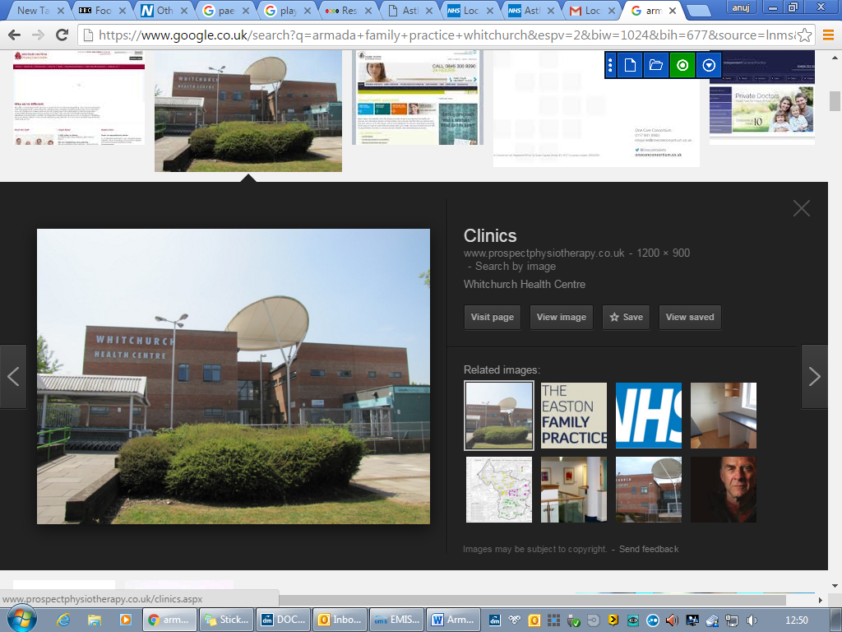
Great opportunity to join a friendly and supportive practice

MSK physiotherapy specialist – 30 hours per week

About us

The Armada Family Practice works from a modern purpose-built health centre with a practice population of circa 16,300 patients. We are looking for an experienced MSK specialist to join our multi-disciplinary team.

Our clinical team comprises of 3 GP Partners, Salaried GPs, Advanced Nurse Practitioners, Paramedic Practitioner, Practice Community Nurses, Practice Pharmacists, Practice nurses, HCAs, GP assistants and a large administration team.

- Excellent employment package
- Compact practice area with easy parking.
- Training Practice
- Daily get together over coffee
- EMIS Web clinical system
- CQC rated “Good”

All our appointments are booked by our experienced care navigation team who ensure that patients are booked in with the right clinicians to help the patient. They use a navigation tool called Sentier’s which has been adapted to meet our needs and appointment system. Helping to ensure the right patient sees the right clinician first time.

Job Description

Main Objectives of Post
- Conduct comprehensive Musculoskeletal clinical assessment for patients over the age of 18 years
- Diagnose and manage a wide range of musculoskeletal conditions following current clinical guidance and evidence-based practice
- Develop and implement individualised treatment and rehabilitation plans
- Provide first-contact practitioner (FCP) services where applicable
- Refer patients for imaging, specialist care, or onward services when clinically appropriate
- Deliver joint injections (if qualified)
- Provide advice on pain management, exercise, and lifestyle modifications
- Support patients with self-management strategies
- Work collaboratively with GPs, physiotherapists, nurses, and other healthcare professionals
- Maintain accurate and up-to-date clinical records

Clinical Duties
- Triage MSK patients in primary care settings
- Identify red flags and serious pathology
- Request and interpret diagnostic investigations (e.g., X-rays, MRI where appropriate)
- Manage acute and chronic MSK conditions
- Deliver patient education and reassurance

Professional Responsibilities
- Maintain registration with relevant professional body (e.g., HCPC
- Engage in continuous professional development (CPD)
- Follow clinical governance and safeguarding policies
- Participate in audits, service development, and quality improvement initiatives

Essential Requirements
- Degree in Physiotherapy,
- HCPC registration
- Relevant postgraduate MSK experience
- Experience working in primary care or outpatient MSK settings
- Strong clinical reasoning and diagnostic skills
- Excellent communication and interpersonal skills
- Ability to work independently and as part of a team

Desirable Skills/Qualifications
- Injection therapy qualification
- Independent prescribing qualification
- Experience as a First Contact Practitioner (FCP)
- Knowledge of NHS pathways and referral systems
- Current IRMER training and competency in requesting appropriate radiological investigations
Salary

- Depending on experience
- We are a visa sponsoring practice

For further information or to apply for this role please contact Victoria Fyfe - Practice manager
Victoria.fyfe1@nhs.net

